Gf
Optimize the Storage Volume using Data Mining Techniques
Title1: A data mining framework to compare efficient optimization of storage locations using sketch-based data placement algorithm and Sine Optimization Algorithm
In this project we are optimizing storage location using Sketch Based algorithm and Sine Optimization algorithm. Suppose you design an online moving watching channel and you want to track count of each movie view then you can HASHTABLE which map each movie_id to its view count and if you have 10000 movies then Hashtable sine optimization will store all 10000 movie names and its count and if each movie require 1 KB size then we need 10000KB size and to optimize this storage space we can use sketch base algorithm which maintain array of multiple rows and column contains hash code of movie id and if user watch that movie then sketch base will store only integer value as 1 and to store value 1 we need only 1 byte of space so with 10000 movies sketch base require 10000 Bytes memory and sine optimization require 10000 KB of space.
You can read about Sketch Based Data Placement from below URL
https://towardsdatascience.com/big-data-with-sketchy-structures-part-1-the-count-min-sketch-b73fb3a33e2a
To run project double click on ‘run.bat’ file to get below screen
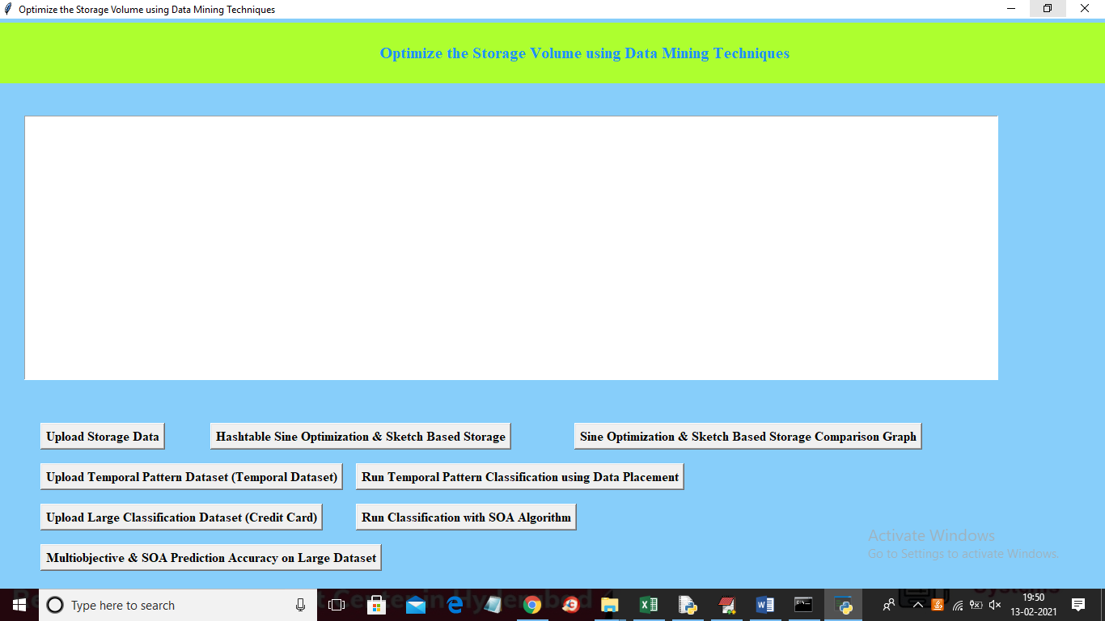
In above screen first row 3 buttons are for title 1 and second row 2 buttons for title 2 and 3rd row 2 buttons for title3 and last button for title 4. In above screen click on ‘Upload Storage Data’ button and upload movie dataset and then application find count of each movie watch and then to store that data application find storage size of both Sketch Base algorithm and Sine Optimization algorithm
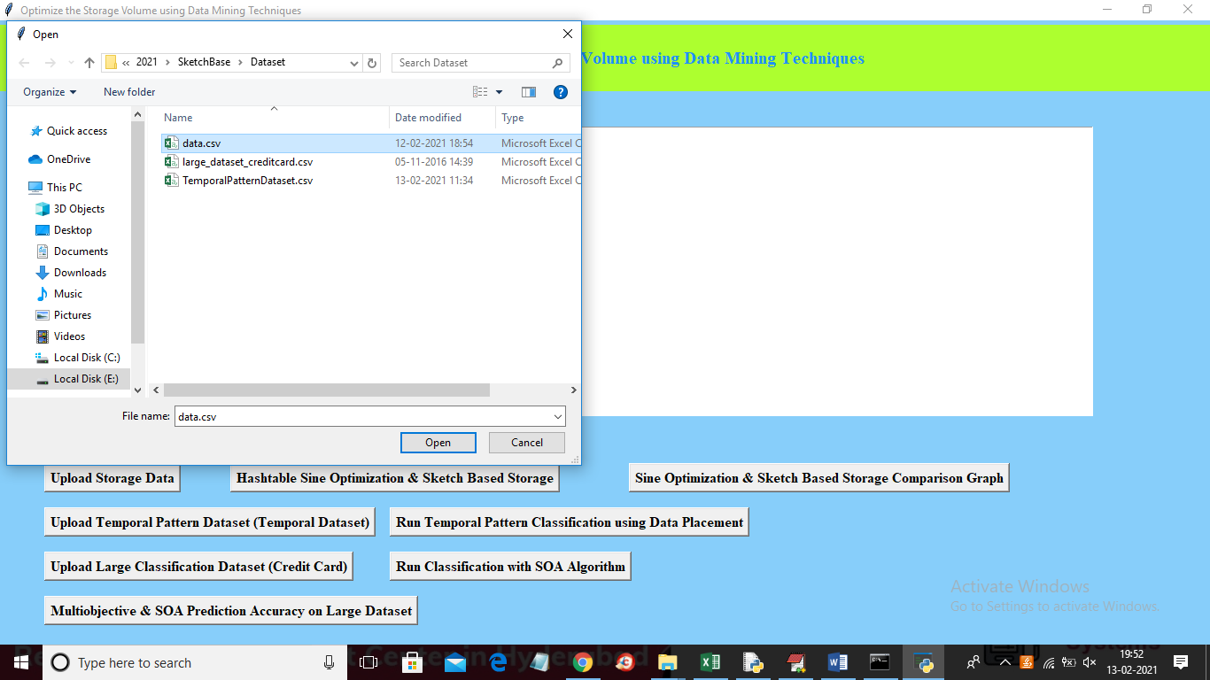
In above screen selecting and uploading ‘data.csv’ file and then click on ‘Open’ button to upload dataset and to get below screen
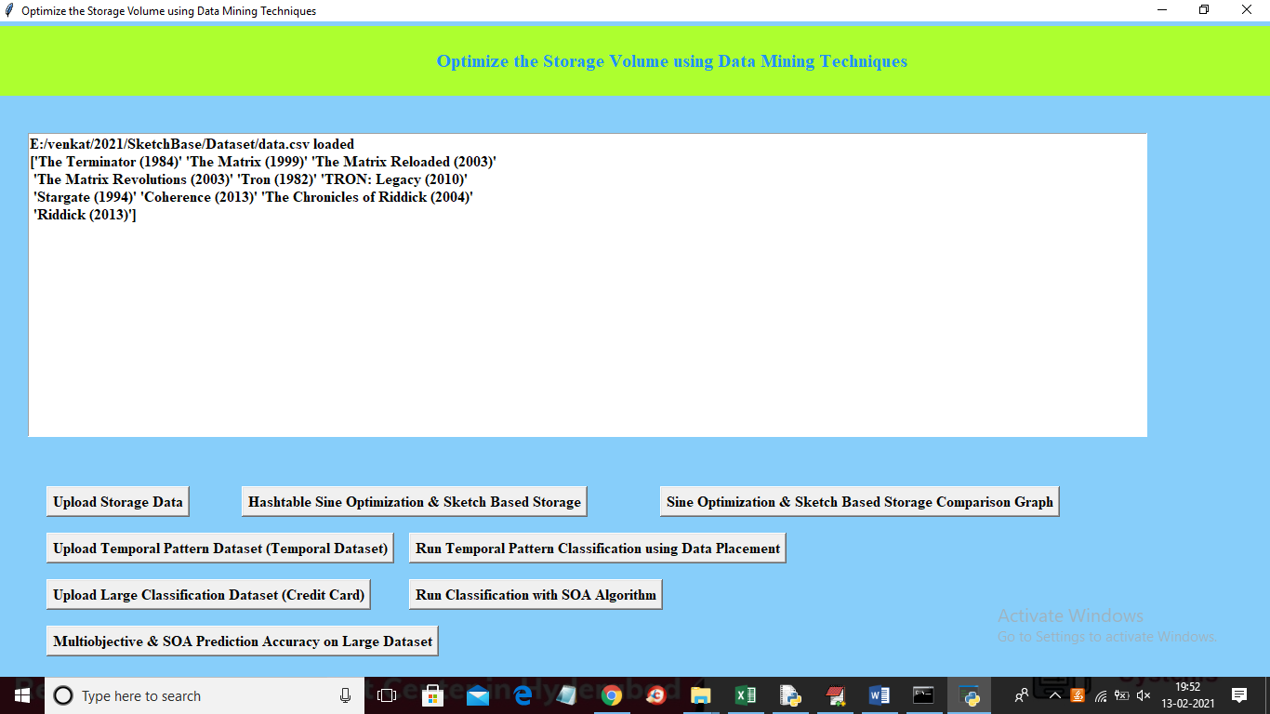
In above screen movie dataset loaded and it contains 10 movies and for each movie we will go for random watch and then find out watch count of each movie and memory storage size and now click on ‘Hashtable Sine Optimization & Sketch Based Storage’ button to get below output
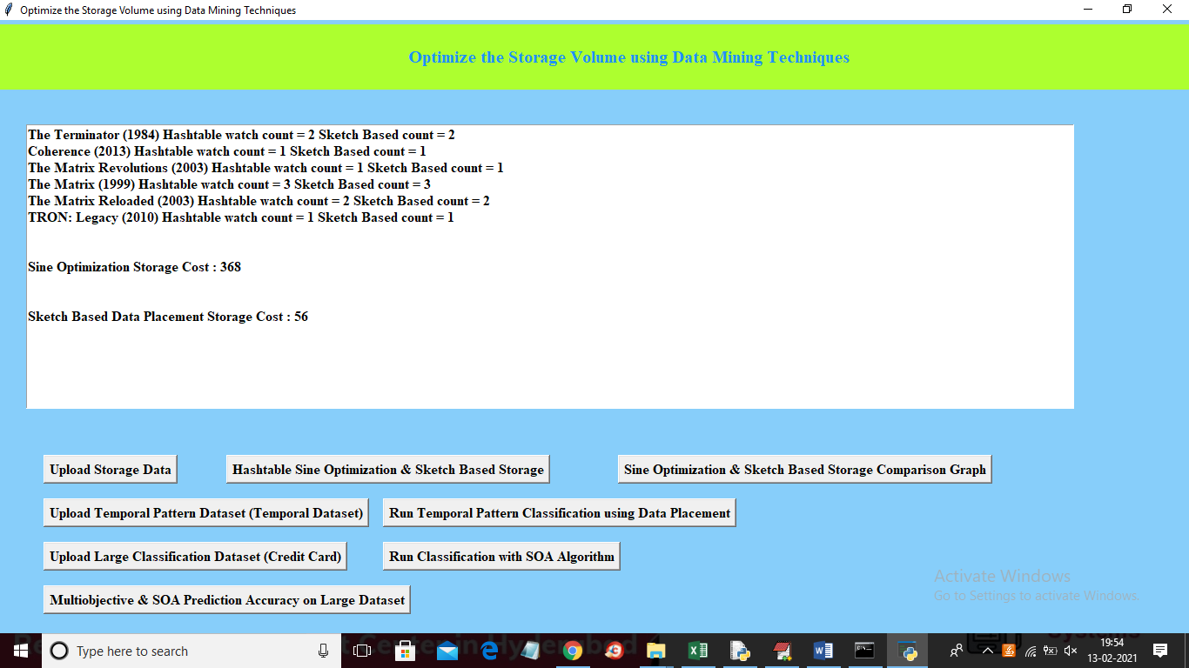
In above screen for each movie we find out count using both sine optimization and sketch based technique and to store same data sketch based too 56 KB size and Sine Optimization took 368 KB size and now click on ‘Sine Optimization & Sketch Based Storage Comparison Graph’ button to get below comparison graph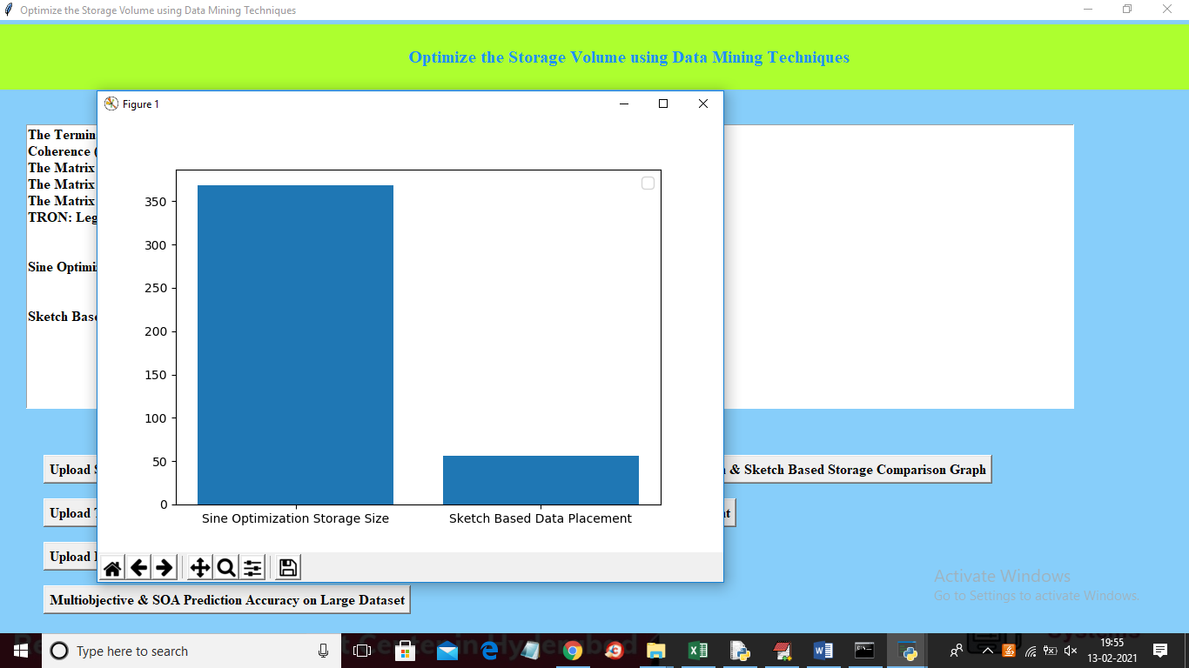
In above graph x-axis represents algorithm name and y-axis represents storage size took by those algorithms.
===============Title 1 output screens end here=======================================
===============Title 2 output screens start here=======================================
Title 2: Temporal Pattern Classification and Analysis of large volume of data using associated data placement algorithm and Online Community Adjustment
In this project we need to classify temporal pattern from large dataset and to implement this task we have use production dataset. Here temporal refers to date or period of time and patterns refers to behaviour and by using this temporal pattern dataset we can predict/classify future behaviour.
For Example: In a manufacturing unit each month or in a day they have to manufacture some 500 products and sometime from that target 500 they can manufacture more or less products and this will form a dataset and by using this past dataset we can train a classification model and by using this model we can predict or classify future manufacturing units/products. Below is the ‘TemporalPatternDataset.csv’ dataset screen shots used to implement this task.
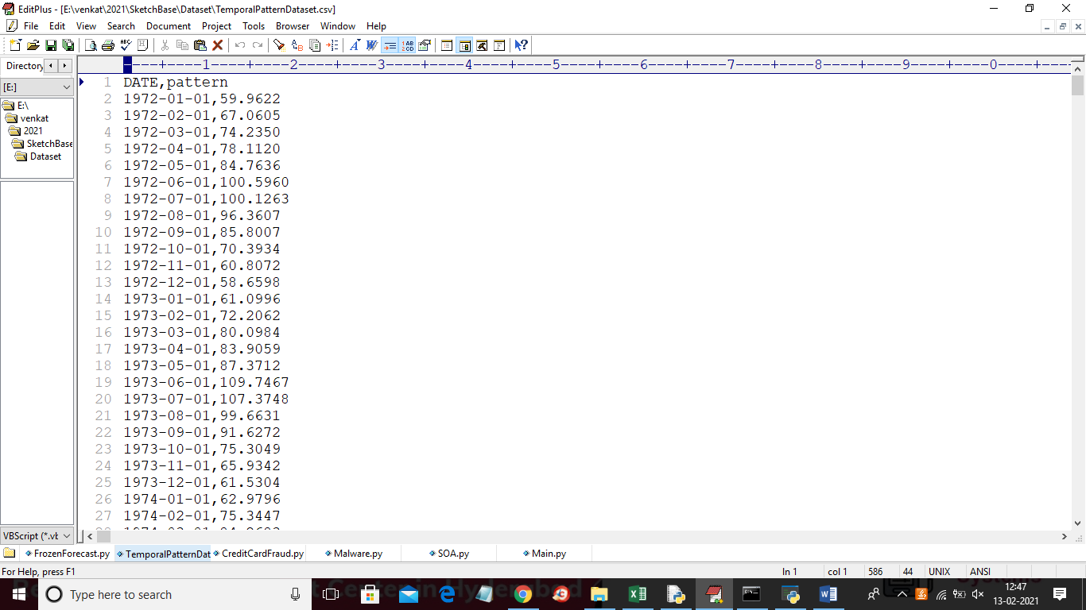
In above dataset we have date and manufacturing products units/behaviour and by using above dataset we can train model and can predict future 30 days manufacturing unit.
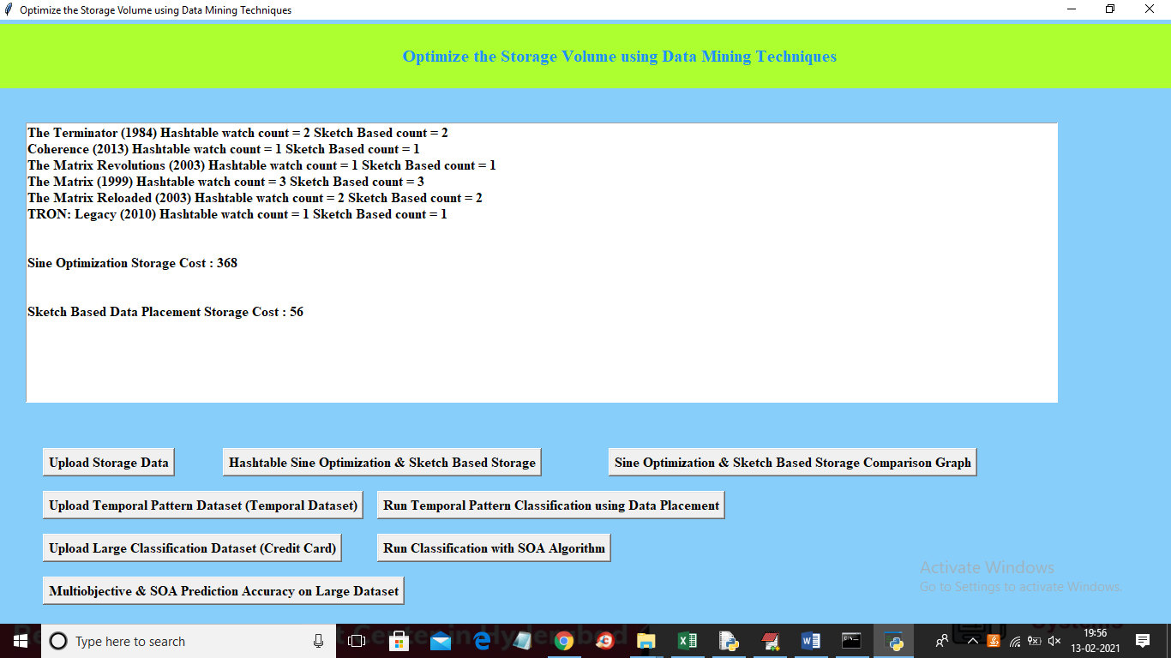
In above screen click on ‘Upload Temporal Pattern Dataset (Temporal Dataset) button and upload temporal dataset
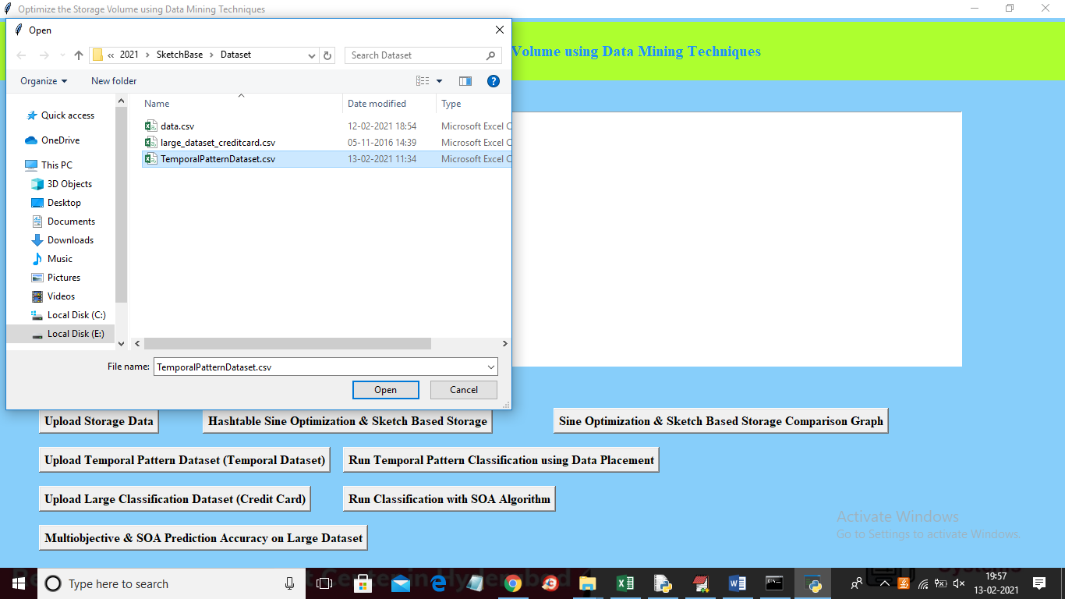
In above screen selecting and uploading ‘TemporalPatternDataset.csv’ file and then click on ‘Open’ button to load dataset and to get below screen
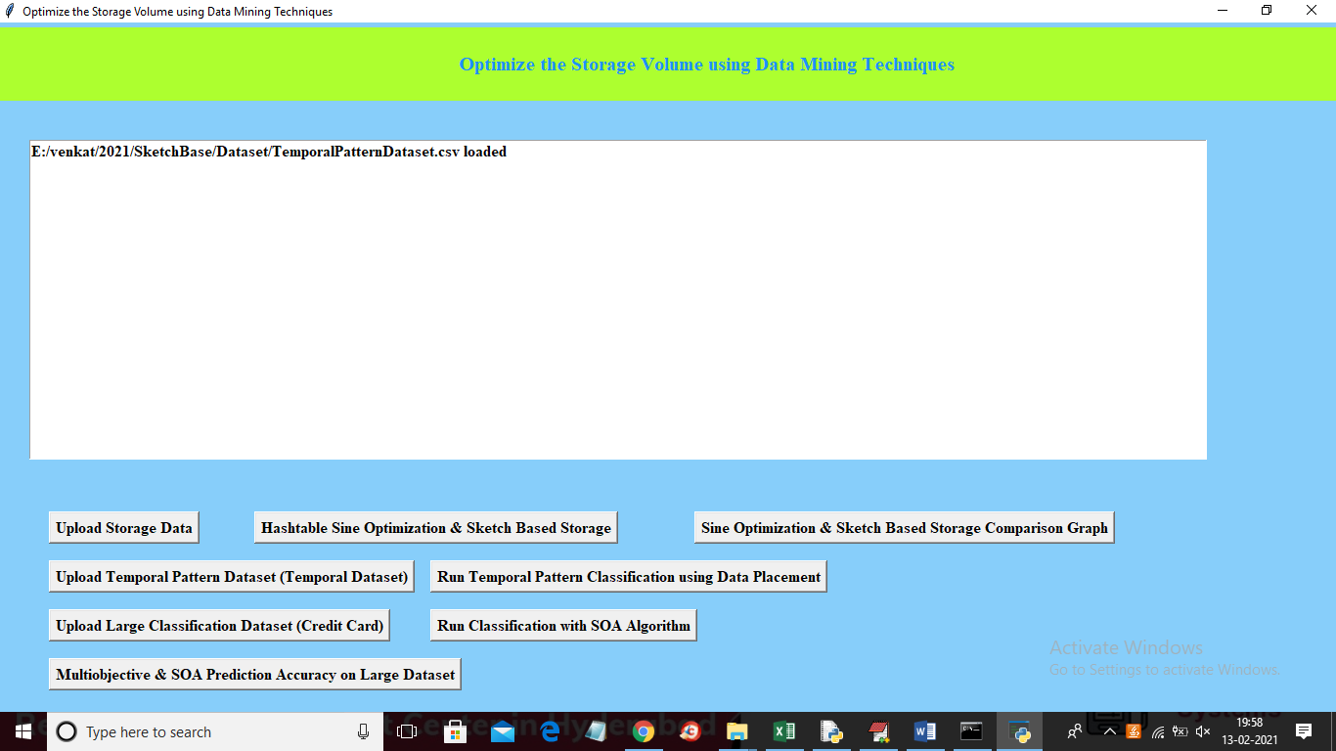
In above screen dataset loaded and now click on ‘Run Temporal Pattern Classification using Data Placement’ button to perform classification on temporal data
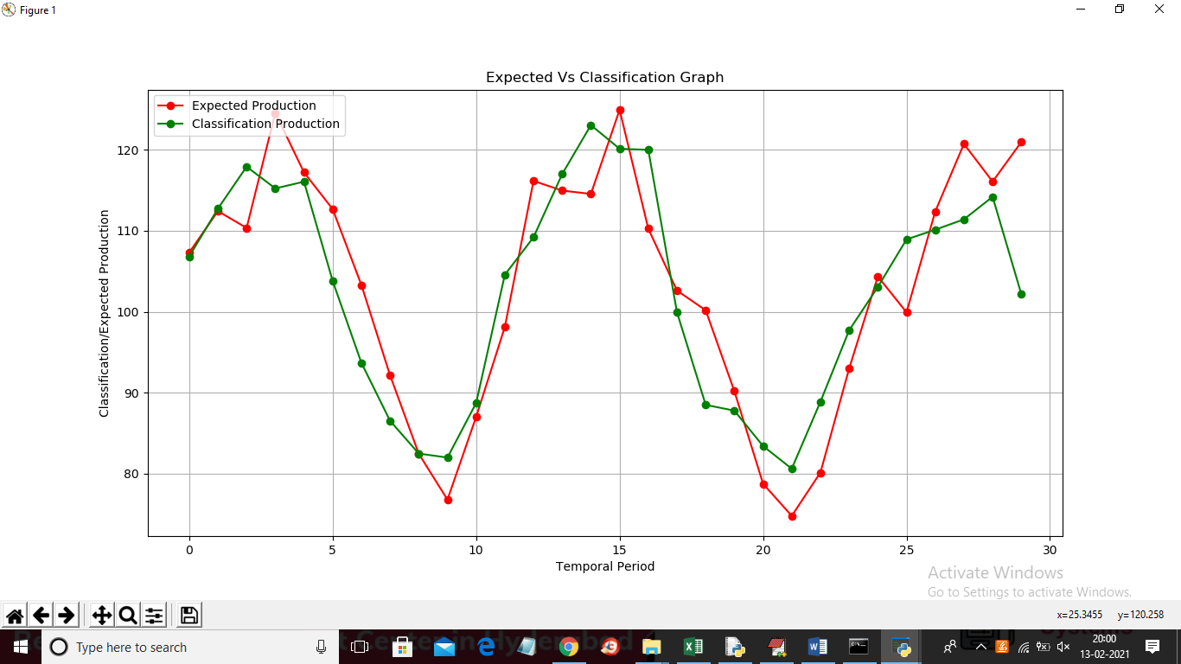
In above graph x-axis represents date/temporal data and y-axis represents expected/classification values and in above graph red line represents expected manufacture unit and green line represents predicted/classified values and in above graph we can see there is only close difference between expected and predicted/classified values and same values we can see in below screen
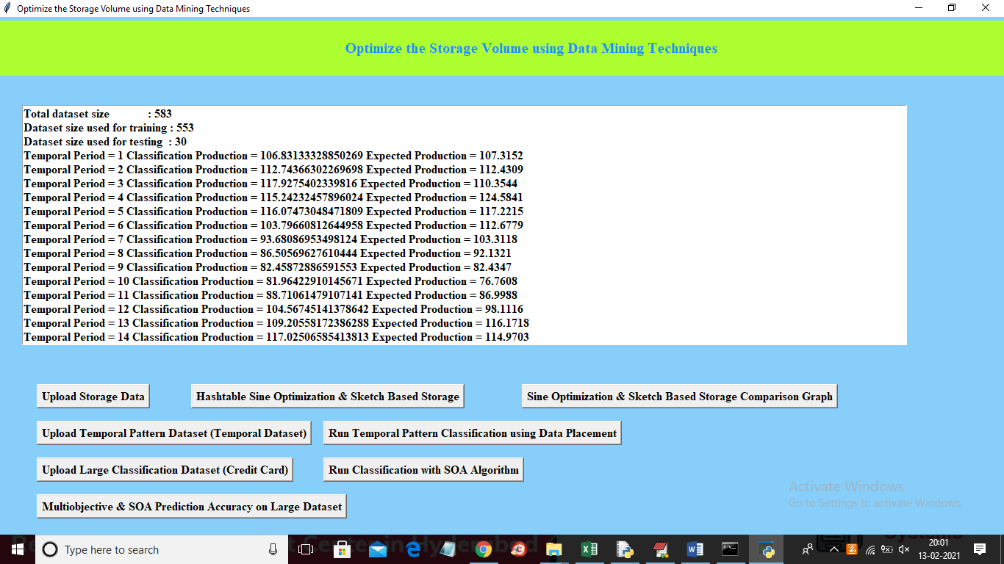
In above screen for training application use 553 records from total 583 records and next 30 records are used to predict values for next future 30 days and in above screen for each day we can see expected and classified/predicted production.

===============Title 2 output screens end here=======================================
===============Title 3 output screens start here=======================================
Title3: Classification of large data storage using SOA algorithm and comparison of accuracy in terms of Distributed Community Discovery Algorithm
In this project we are using large credit card fraud dataset which contains 30 lakhs records and by using this dataset we are classifying transaction into two classes called ‘NORMAL’ or ‘FRAUD’ transaction. To optimize or to choose important features from this dataset we are applying Sine Optimization Algorithm and this algorithm will calculate importance of all features and if feature importance or similarity value between other features closer to 1 then it will consider as important features and if value closer to 0 then it will consider as unimportant features and it will be removed out from dataset and only use important features to train classification model. After building model we are calculating classification accuracy by applying trained model on test data. Below screen shots showing details from credit card fraud dataset
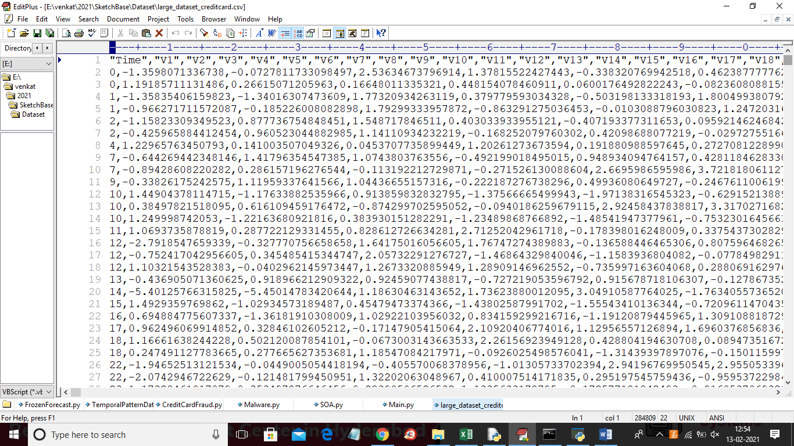
Now in previous old screen shots click on ‘Upload Large Classification Dataset (Credit Card)’ button and upload large dataset and to get below screen
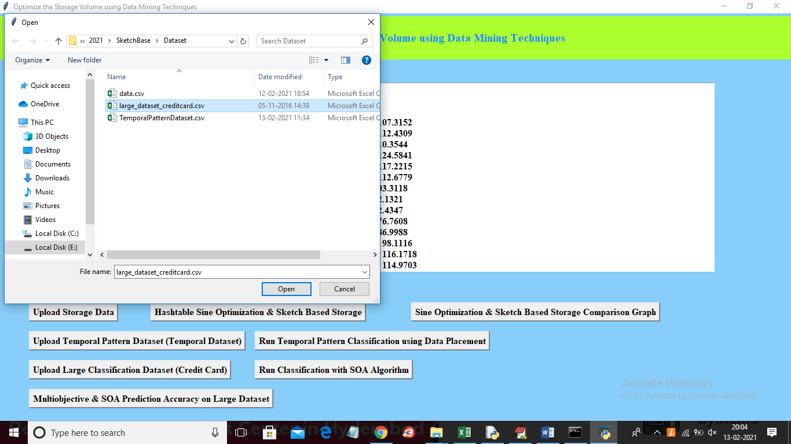
In above screen selecting and uploading ‘large_dataset_creditcard.csv’ file and then click on ‘Open’ button to load dataset and to get below screen
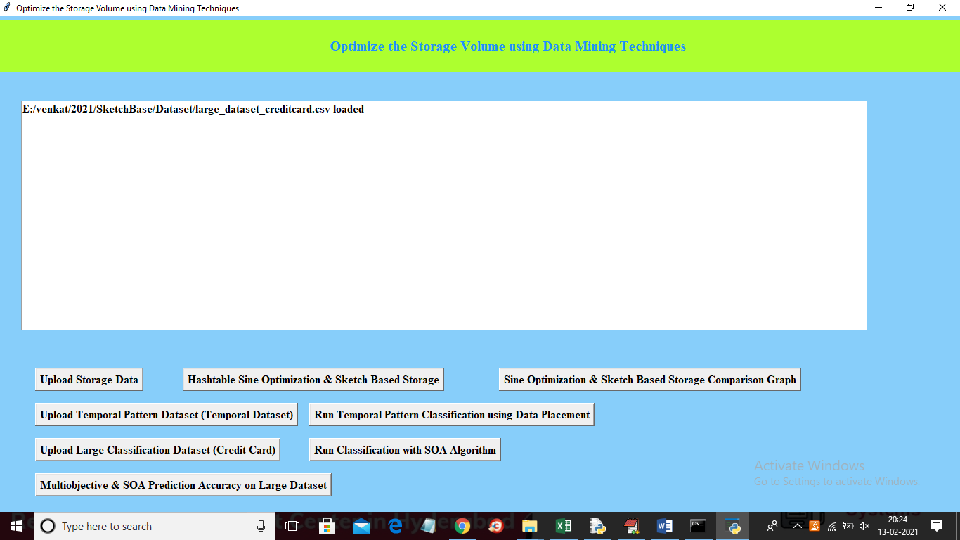
In above screen dataset loaded and now click on ‘Run Classification with SOA Algorithm’ button to optimize dataset features with SOA algorithm and then calculate accuracy
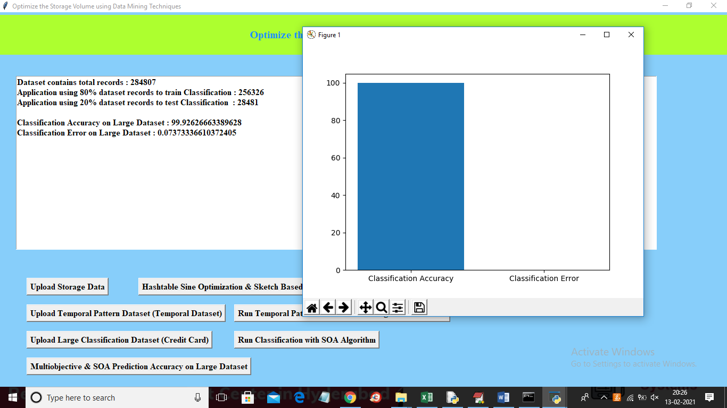
In above screen we can see dataset is too large and contains more than 2 lakhs records and then application using 256326 records to trained algorithm and 28481 records to test trained algorithm and we got classification accuracy is 99.92% and its error rate is too much less and we got this high accuracy due to dataset features optimized with SOA algorithm and in above screen graph we can see error rate bar is not displaying as its value is too less.
===============Title 3 output screens end here=======================================
===============Title 4 output screens start here=======================================
In title 3 we optimized dataset features with SOA algorithm and in title 4 we are optimizing dataset features with multi objective (genetic algorithms0 features optimization algorithm and then calculating its accuracy and comparing with SOA algorithm accuracy. Now to run multi objective algorithm click on ‘Multiobjective & SOA Prediction Accuracy on Large Dataset’ button to run multi objective feature optimization algorithm and to get below output.
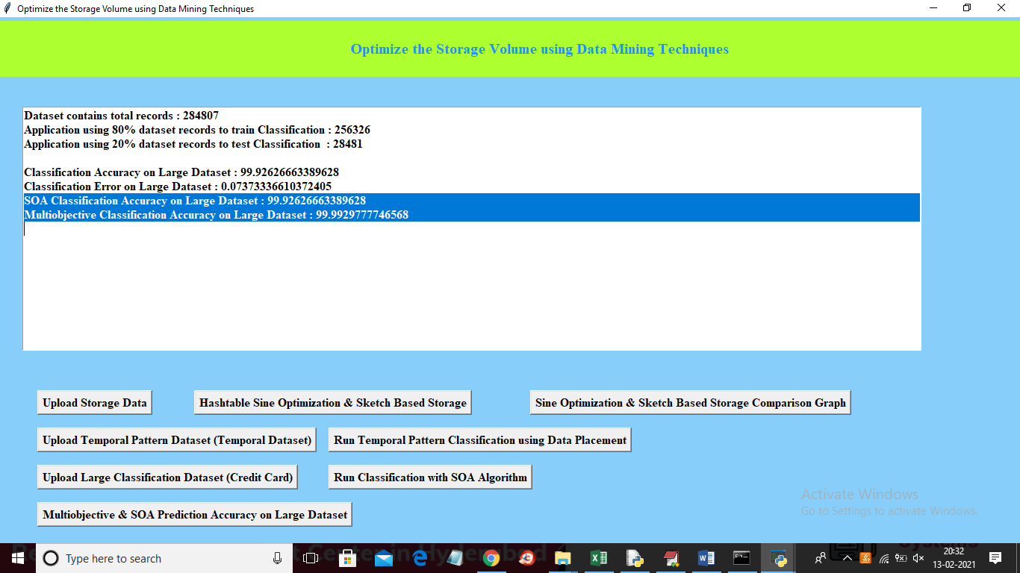
In above screen in selected text we can see SOA classification accuracy is 99.92% and multi objective accuracy is 99.99% and from above value we can conclude that multi objective is better than SOA technique and now we can see below accuracy comparison graph between two algorithms
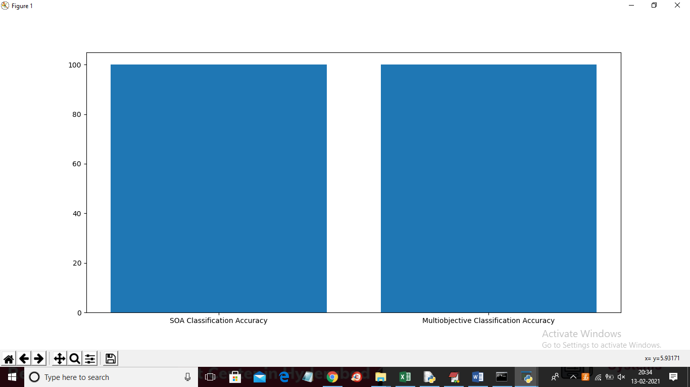
In above graph x-axis represents algorithm name and y-axis represents accuracy of those algorithms and in above graph between two algorithms accuracy difference is too less but SOA got 99.92% and multi objective got 99.99%
===============Title 4 output screens end here=======================================

